German Bundesliga – Final no 1
Sporthalle an der Lohschule, Hamm
April 27, 2024

MBR 31/46 Hamm - BC Traktor Schwerin 10:10

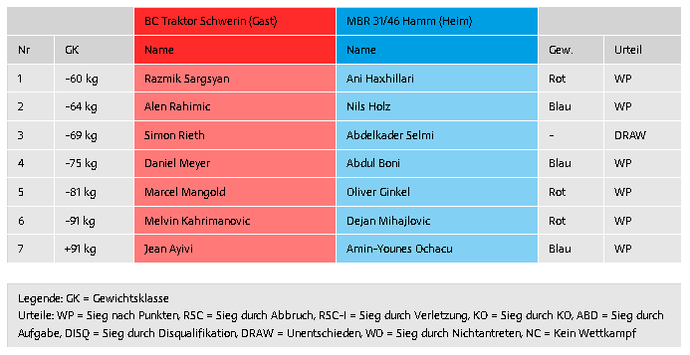

source: https://www.boxverband.de/
________________________________________________________________________________________________

2024 Bundesliga Season | 2024 Results

